**relational model and his corresponding data types tables**

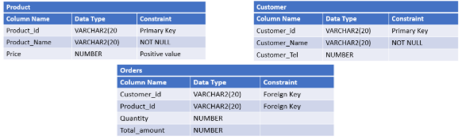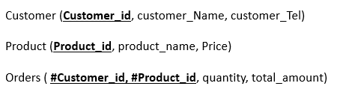

CREATE TABLE customer (

Customer_Id data VARCHAR(20) CONSTRAINT pk_constraint PRIMARY KEY,

Customer_Name VARCHAR(20) CONSTRAINT nn_constraint NOT NULL ,

Customer_Tel NUMBER,

);

CREATE TABLE Product (

product_Id data VARCHAR(20) CONSTRAINT pk_constraint PRIMARY KEY,

product_Name VARCHAR(20) CONSTRAINT nn_constraint NOT NULL ,

price NUMBER CONSTRAINT positive_constraint CHECK (price > 0)

);

CREATE TABLE Orders (

Customer_Id data VARCHAR(20)

product_Id VARCHAR(20) ,

quantity NUMBER,

Total_amount NUMBER,

CONSTRAINT fk1_orders FOREIGN KEY (Customer_Id) REFERENCES customer (Customer_Id),

CONSTRAINT fk1_orders FOREIGN KEY (product_Id) REFERENCES Product (product_Id),

);